Module: Information
Sub Module: Notice,Circular, Minutes

First part contains select button which has following option: screen shot – 01
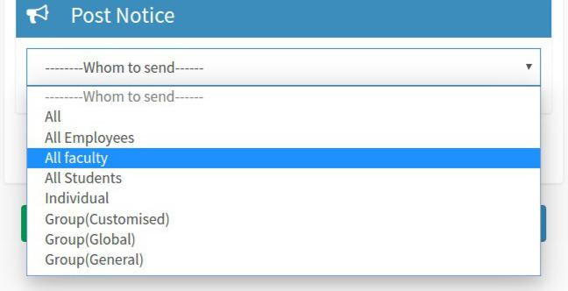

- All → This notice will be visible to all the people.
- All Employees → this notice will be visible to all employee.
- All Faculty → this notice will be visible to all faculty
- All Students →this notice will be visible to all student
- Individual → fill the admission id or emp_id of user who can see.
- Group Customized → visible to user which belong to group which is local to sender.

- Group Global → visible to user which belong to group which is same for every recipient.

- Group General → general group can be possible like faculty of department.

Step 1:
  - select any of above option according to your requirement

  - Option 1- 4 does not require any further step just click post.

- Individual

Part1:
Steps:
1.Enter the No. of Person
- Enter the admission no./ employee_id of user in left box which has been apear.

- if you don't know the admission no or emplyoee id then go part 2:

Screen shot – 02
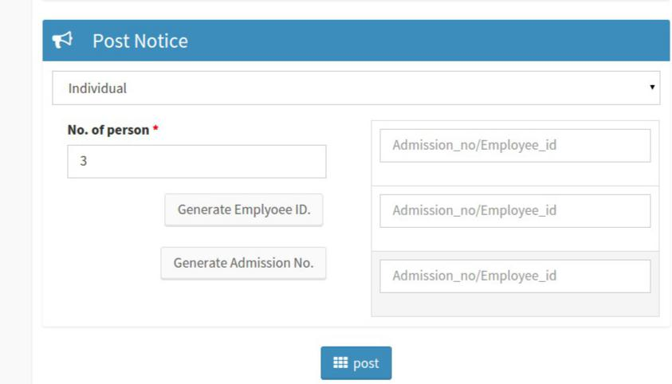

Part2:
(don't know Employee id)
- Generate Employment id
  - Click the button 'Generate Employee Id' II)Select the department of user in below box.

III) Select the employee name in below box IV) fill the employee id in left boxes for user

Screen shot -03
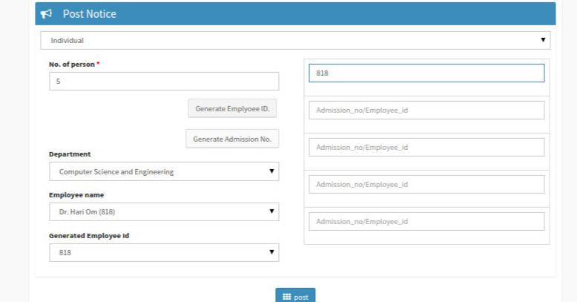

- Generate Admission No.
  - Click the button 'Generate Admission No.' II)Select the department of user in below box III)Select the course of user in below box.

IV) Select the employee name in below box
  - fill the employee id in left boxes for user

Screen shot -04
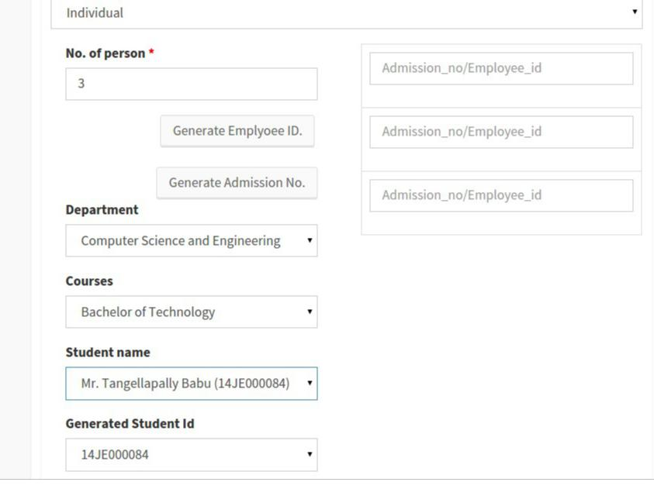

6. Group Customised
part1:

Create Group:

I) click on create group button lower left corner of notice II) It will open create group page in new tab

III) fill the name of group which you want to create group name should not contain spaces.

IV) search the your user with specified field in Add member box. V) Click Add button right side of user name
VI) Added member will be shown on above Add member box as Added member.
VII) Click remove button after added member to remove the member from group
Screen shot -05
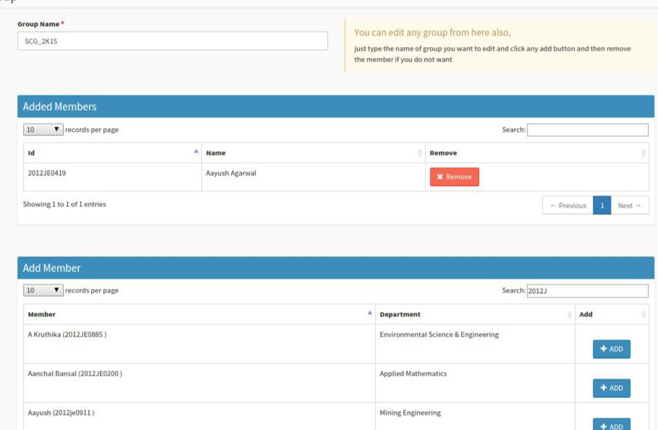

Part 2) Delete Group
- click the delete button lower central button of notice.

- you will redirected to delete group page.
- select the group you want to delete.
- All the member of that group will visible
- click on the delete button.
Screen shot -05
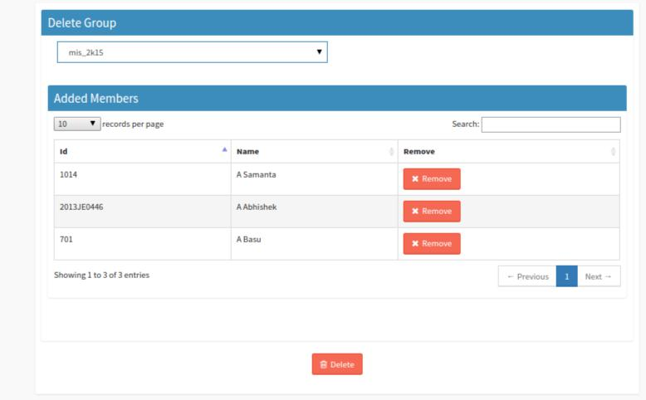
Part 3) Edit Group

I) Click on edit button on lower right corner. II) it will redirected you to edit _group page. III) select the group which you want to edit.

IV) All the member of the group will shown below as added member
V) Click remove button right of user to remove the user from group in added member box.
VI) Click add button right of user to add the user to group in Add member box.

Screen shot -06
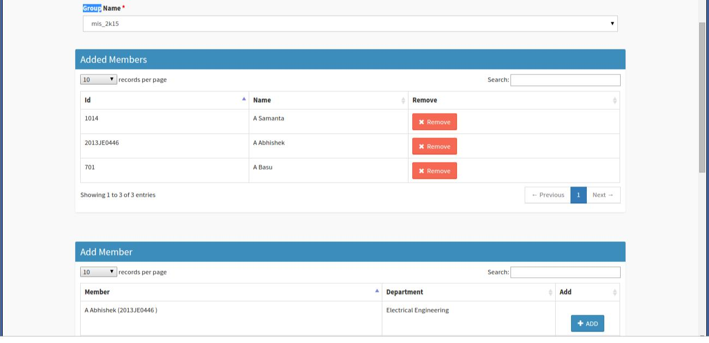

7. Group Global
all the step are same as group customized. Only we have to go through header.

8. Group General

Following are special categories of user that can you can send
- All the employee of a particular department or to all department.
- All the student of a particular course , department or semester.
- All the faculty member of any department
- At default it will select all for any selection
steps:
- select categories and department for posting the notice.
- if you have selected employee then types of faculty box will appear

- select the facutly or non facutly .

Screen shot – 07
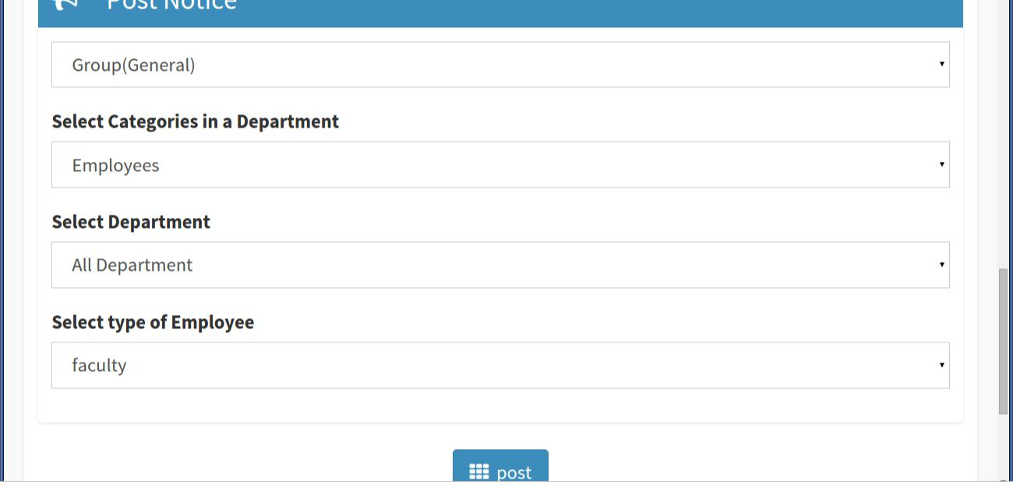

- if you have selected student then course box will appear.
- after selecting course semester box will appear.
Screen shot -09
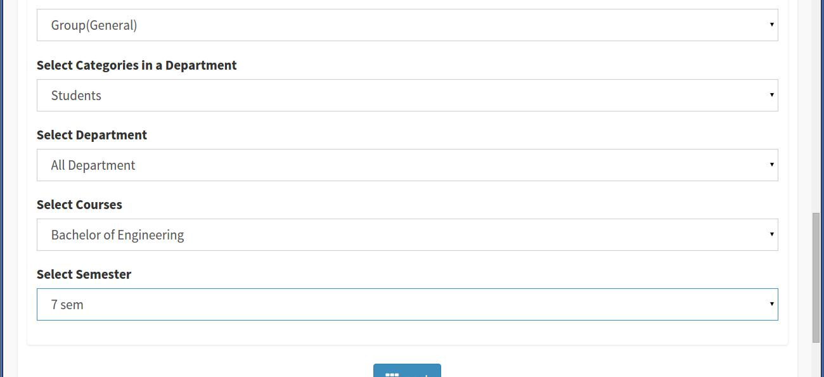

Note – cirular and minutes same steps.

